**Module-1 – Lab assessment**

Date: 31st Jan 2022 Time: 2 hours

**Lab 1.** Complete the lab and design a solution as per given architecture and tasks.

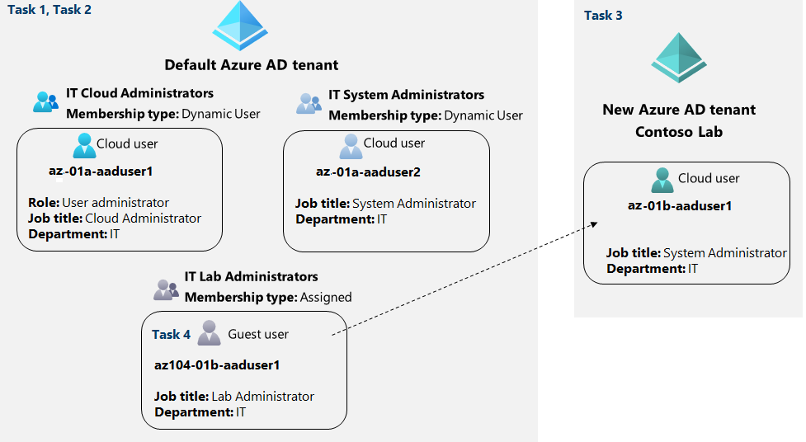

* Task 1: Create and configure Azure AD users **az-01a-aaduser1** and **az-01a-aaduser2**
* Task 2: Create Azure AD groups **IT Cloud Administrators and IT System Administrators** with dynamic membership and create the rule for assigning the members based upon Job title. Create **IT Lab Administrators** group with membership type as assigned.
* Task 3: Create an Azure Active Directory (AD) tenant named **Contoso Lab**
* Task 4: Manage Azure AD guest users.
  + In Contoso Lab Azure AD tenant, create a new user **az-01b-aaduser1 with given Job title System Administrator and department IT.**
  + Switch back to your default Azure AD tenant and add **az-01b-aaduser1 as a guest user with given Job title Lab Administrator and department IT.**

Document the solution by taking the screenshot of each task to reflect the output.

**Lab2.** Create a storage account named “<your name>lab2sa (for example puneetlab2sa) and perform the following tasks.

* Create a policy to restrict the storage to specific region.
* Create the blob with public access and try to access the URL.
* Switch the blob access level from public to private and try to access the same URL again.
* Create SAS key token and then try to access the blob URL with SAS token.
* Switch the access tier from hot to archive and try to access the URL.
* And then rehydrate the access tier back to hot and try to access the blob URL.

Take the screenshot of each task to reflect the output.